PCOC & Univar Present
PestEd 2015
January 13th & 15th * January 13th & 15th * January 13th & 15th * January 13th & 15th * January 13th &15th
6 CEU Hours applied for with SPCB & DPR  Hours For:  Rules & Regs Branch III Branch II  & Applicators Hours  Registration begins at 7:30am  FEES  PCOC Members:  $75  Non-Members:  $110  *After December  26th fees will  increase by $20! Please make sure to register early! |  | CONTINUING EDUCATION HOURS OFFERED FOR: OPERATORS, FIELD REPRESENTATIVES AND APPLICATORS  Please join us on:  January 13, 2015 - Montebello’s Quiet Cannon  901 N Via San Clemente  Montebello, CA 90640  January 15, 2015 - Woodlake Hotel Sacramento  500 Leisure Lane  Sacramento, CA 95815  CEU Hours: All participants attend the three hour morning general session. 1 hour of Rules & Regulation and 2 hours of IPM are being applied for. NOTE: HOURS MAY VARY DEPENDING ON BOARD & DPR APPROVAL. After lunch is served, participants will attend one of the three breakout sessions for the afternoon session, for a total of six continuing education hours.  The three options for the afternoon session are:  • 3 Hours of Rules & Regulations  • 3 Hours of Branch 3 Technical  • 3 Hours of Branch 2 Technical  Registration: Pre-registration for PCOC Members is $75.00 and for  Non-Members it is $110.00. The Late registration fee will be $95.00 for PCOC Members and their employees and $130.00 for Non-Members. The cutoff date for early registration will be December 26, 2014. It is highly recommended that you register in advance. Seating is limited. Once seating capacity is reached, registration will be closed. Register today and reserve your seat!  Lunch will be provided  Reserve a seat with a credit card by faxing to (916) 372-5437 or by mailing the attached form to PCOC. One registration form per person.  Please fill out the attached registration form for each attendee.  PestEd is Sponsored by:  AP&G BASF Bayer Bell Labs B&G CSI FMC  Mattress Safe Nisus Modern Methods PestWest  Protect-A-Bed Syngenta Zoecon PCOC Insurance/Epic  Zoecon

PestEd 2015 Registration Form

Name: Date:

Company Name:

License Type: RA FR OPR License # Mailing Address:
City: State: Zip:

Registration begins at
7:30am! Reserve your spot early!

Phone Number: Fax Number: Which day will you attend? (Please circle one):
January 13th—Montebello January 15th—Sacramento

Method of Payment: Check Credit Card Credit Card Type: Credit Card #: Expires: V-Code:

Billing Address: City: State: Zip Code:

Signature: Please Print:

Please indicate which afternoon class you will be attending for an additional 3 hours. Check Only One

Check One:
Branch 3 Technical Branch 2 Technical Rules & Regulations

Check One:

PCOC Member $75
(Prior to 12/26)

Non Member $110
(Prior to 12/26)

Member Late Registration $95
(After 12/26)
Total Amount Due $

Non Member Late Registration $135
(After 12/26)

*NO REFUNDS OR CANCELLATIONS AFTER JANUARY 3, 2015*

Mail your registrations to PCOC, 3031 Beacon Blvd, West Sacramento, CA 95691
If you have any questions, please feel free to call PCOC at: (916) 372-4363 OR Fax Registration to (916) 372-5437

Quiet Cannon
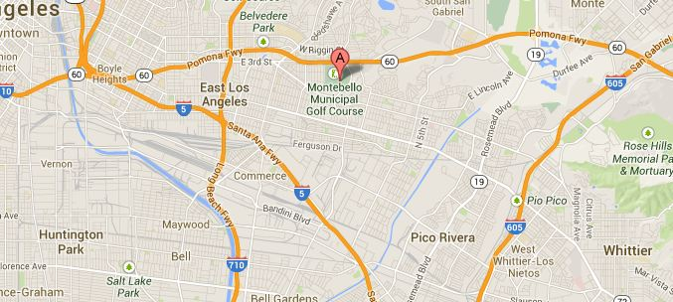

901 N Via San Clemente
Montebello, CA 90640

WoodlakeHotel
500 Leisure Lane
Sacramento, CA 95815

12 / Wednesday, January 11, 2012

